

BCSE417L – MACHINE VISION LAB

EXPERIMENT 4: Implement Contrast Enhancement of an Image without using OpenCV
EXPERIMENT 5: Compare Different Smoothing Methods using OpenCV

SUBMITTED BY-
22BAI1118 – Mayank Raj

SUBMITTED TO-
Trilok Nath Pandey
Date: 14/02/2025

Introduction
This lab experiment focuses on two primary tasks in image processing:
- Implementing contrast enhancement without using OpenCV
- Comparing different image smoothing methods using OpenCV

Input Image


Task 1: Contrast Enhancement Implementation
Methodology
The contrast enhancement task was implemented using pure Python and basic libraries (PIL and NumPy) through the following steps:
- Image Loading
  - Utilized PIL (Python Imaging Library) for loading the image
  - Implemented in the load_image_pil() function
def load_image_pil(image_path):
return Image.open(image_path)

- Grayscale Conversion
  - Implemented manual RGB to grayscale conversion using the standard luminosity formula
  - Weights used: R (0.2989), G (0.5870), B (0.1140)
grayscale = (0.2989 * R + 0.5870 * G + 0.1140 * B)
- Contrast Enhancement
  - Applied histogram stretching technique
  - Formula: output = (input - min) * 255 / (max - min)
  - This stretches the pixel values to utilize the full range (0-255)

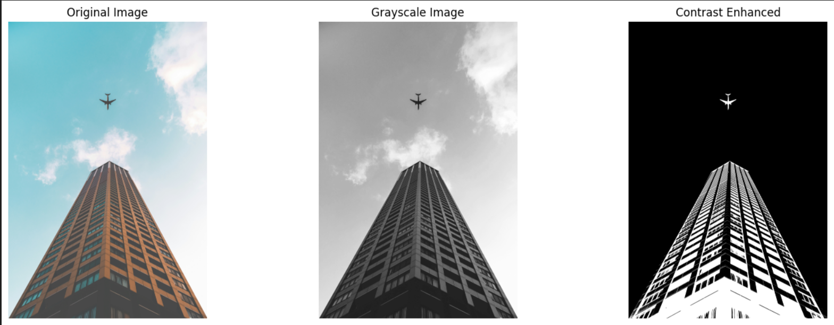

Task 2: Comparison of Smoothing Methods
Implementation Details
Four different smoothing techniques were implemented using OpenCV:

# Averaging Filter
averaging = cv2.blur(img, (kernel_size, kernel_size))

# Gaussian Blur
gaussian = cv2.GaussianBlur(img, (kernel_size, kernel_size), sigmaX=5)

# Median Blur
median = cv2.medianBlur(img, kernel_size)

# Bilateral Filter
bilateral = cv2.bilateralFilter(img, d=15, sigmaColor=150, sigmaSpace=150)

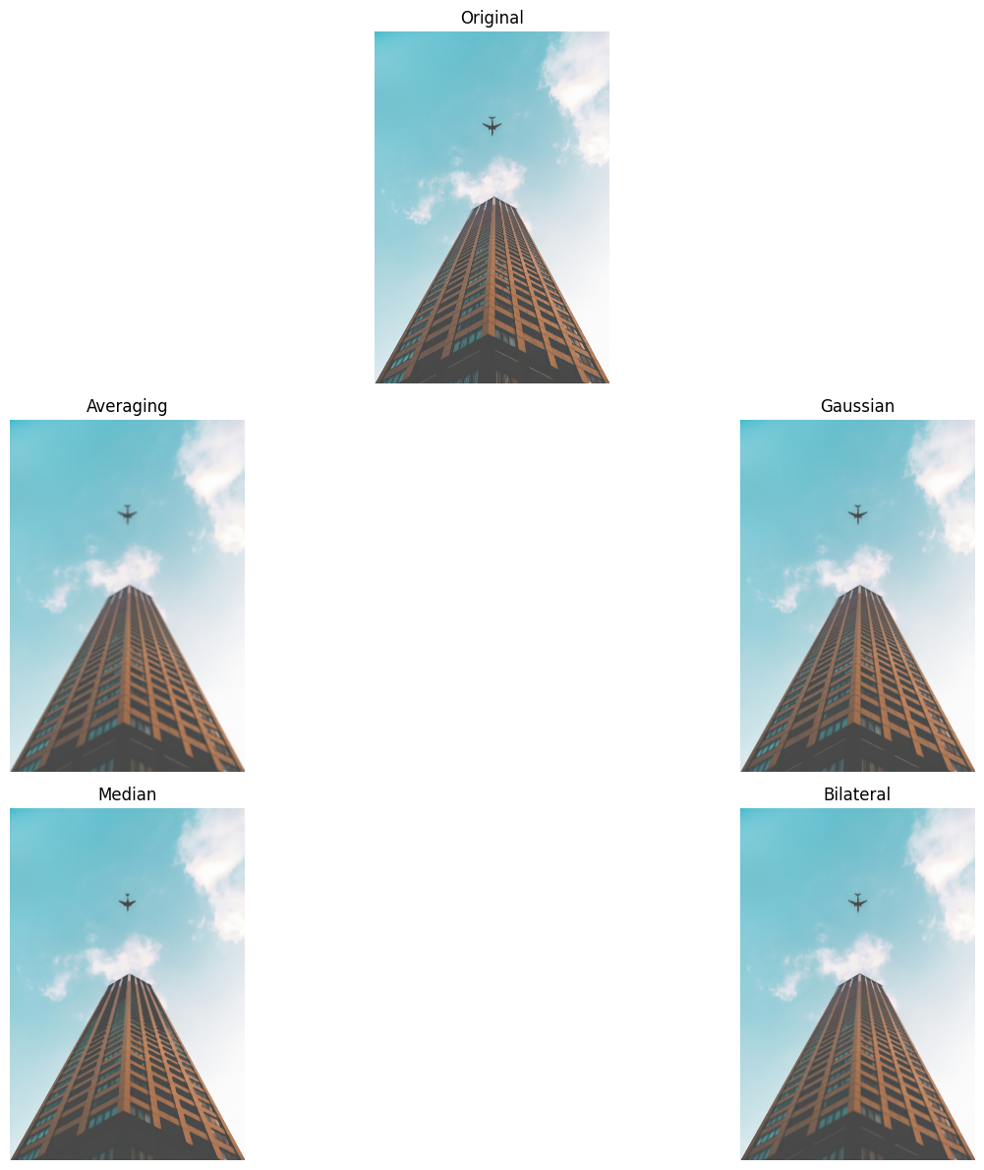

Analysis of Results
Averaging Filter
- Observations: The Averaging filter produced a very blurry image. While it reduced noise, it also caused a significant loss of detail, making the image look overly smooth and washed out. The edges, especially around the building and the plane, became less sharp.
- Advantages:
  - Simple and effective for removing random noise
- Disadvantages:
  - Blurs edges and fine details, leading to loss of sharpness
Gaussian Blur
- Observations: The Gaussian Blur showed a more natural smoothing effect compared to the averaging method. The noise was reduced effectively, but some fine details were still visible. However, the edges were still slightly blurred, making it less ideal for applications requiring sharp boundaries.
- Advantages:
  - Provides better noise reduction while maintaining some details
- Disadvantages:
  - Still causes edge blurring, though less severe than the averaging filter

Median Filter
- Observations: The Median filter performed well in noise reduction, particularly for salt-and-pepper noise. Unlike the averaging and Gaussian methods, it preserved edges better. The details of the building were clearer compared to the previous two methods, though the overall image still looked somewhat softened.

- Advantages:
  - Excellent for removing salt-and-pepper noise while preserving edges
- Disadvantages:
  - Can distort fine textures and is less effective for Gaussian noise
Bilateral Filter
- Observations: The Bilateral filter provided the best balance between noise reduction and edge preservation. While it smoothed the background and sky effectively, the edges of the building and plane remained sharp. This method retained more details compared to the other filters, making it the most visually appealing for preserving structural elements.
- Advantages:
  - Best at reducing noise while preserving edges and fine details
- Disadvantages:
  - Computationally expensive compared to other methods

Summary and Conclusions
The comparison of different smoothing methods revealed that while all methods effectively reduce noise, they each have specific strengths and trade-offs:
- The Bilateral filter proved most effective for applications requiring both noise reduction and edge preservation, despite its computational cost.
- The Median filter offered a good balance between noise reduction and detail preservation, particularly for salt-and-pepper noise.
- The Gaussian and Averaging filters, while computationally efficient, showed significant edge blurring, making them more suitable for applications where edge preservation is not critical.
These findings suggest that the choice of smoothing method should be based on the specific requirements of the application, considering factors such as:
- Type of noise present in the image
- Importance of edge preservation
- Available computational resources
- Real-time processing requirements

